Christopher Columbus and the Genocide of the Taino Nation

http://socyberty.com/history/christopher-columbus-and-the-genocide-of-the-taino-nation/
by Auron Renius in History, June 14, 2009

Christopher Columbus is well known for discovering the New World and is seen as a hero of medieval exploration by many scholars today. However, what many text books fail to mention is the fact that he was a genocidal maniac who set in motion what would become probably the worst case of genocide imposed on one nation of human beings by another.
Obsessed with finding a sea rout to Asia and the Far East, Columbus set out on his ‘Enterprise of the Indies’ in 1492, backed by King Ferdinand and Queen Isabella of Spain. However, instead of finding a rout to the rich trade in the East, Columbus and his crew discovered the New World, and soon set about subjugating and murdering the local population and removing the vast wealth from the land.
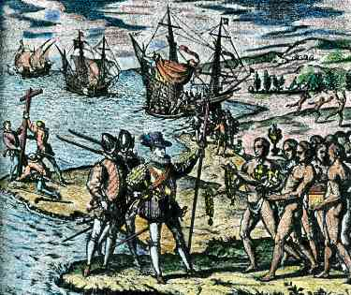
Columbus discovering the New World. Image Source
A small colony was established in Hispaniola consisting of thirty-nine of his crew, the rest returned to Spain with Columbus along with gold, spices and natives taken as slaves to be given as gifts for his royal patrons.
The following year, he led a second expedition comprising of seventeen large ships and one and half thousand new colonists, arriving in the Americas a month later. By the time he got back to Hispaniola, his men there had been slaughtered by the locals and a second colony was founded.
Columbus punished the local tribe, known as the Taino, severely. He enslaved many and executed many more; according to Ward Churchill, former professor of ethnic studies at the University of Colorado, by 1496, the population had been reduced from as many as eight million to around three million.
On his third expedition, he explored the region before returning to Hispaniola in 1498 where he had left his brothers in charge, Diego and Bartholomew. Conditions there were in decline so he stepped up the terror campaign against the Taino, ruling with an iron hand causing resentment from the colonists and local chiefs alike. Complaints of his brutality got back to the Spanish monarchs and in 1500 they sent a Chief Justice to bring him and his brothers back to Spain in chains.
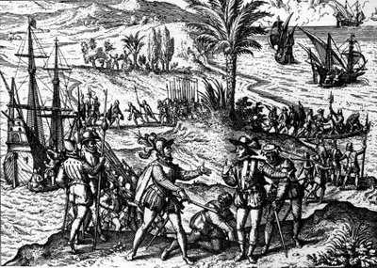
Columbus in chains. Image Source
However he was released on his arrival and allowed a fourth and final expedition, which he conducted with the same brutality as previous ones. By the time he finally left in 1504, the Taino had been reduced to around 100,000 people arguably making Columbus a war criminal by today’s standards and guilty of committing some of the worst atrocities against another race in history.
Some were killed directly as punishments for ‘crimes’ such as not paying tribute to the invaders. Many who could not or would not pay had their hands cut off and were left to bleed to death. Columbus and his men are documented by the chronicles of Las Casas, know as Brev’sima relaci-n, to have partaken in mass hangings, roasting people on spits, burnings at the stake and even hacking young children to death and feeding them to dogs as punishment for the most minor of crimes. The Spanish masters massacred the natives, sometimes hundreds at a time for sport, making bets on who could split a man in two, or cut a head off in one blow.
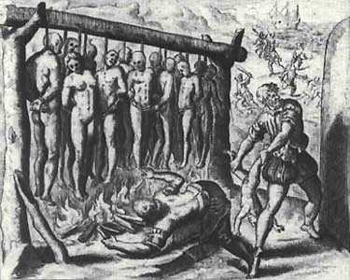
Taino people being tortured by the Spanish. Image Source
Defenders of Columbus argue that a large amount of the victims were killed by disease however they fail to recognize that most of these diseases were caused by poor living conditions in forced labour camps. Deprived of their crops and fields, many fell prey to dysentery and typhus, were worked to death or were left to starve to death.
After his death his terrible legacy would live on, by 1514, a census showed only 22,000 Taino remained alive. By 1542 there were only 200 remaining and after they were considered extinct, as was becoming more and more the case throughout the Caribbean basin.
In around fifty years Columbus and those that followed him had all but eliminated a population of around fifteen million people. This process was just the start and an estimated 100 million people were wiped out by Europeans in the so called ‘civilisation’ of the Western Hemisphere making the discovery of the New World the start of what was arguably the worst case of mass genocide in history.
Read more: http://socyberty.com/history/christopher-columbus-and-the-genocide-of-the-taino-nation/#ixzz2HQQsqhXX

