Name_____________________________________________________________Date______
Due: 5/23/14
As you read through each section, be sure you are taking active reading notes and completing each step outlined below:
- Use at least 2 color markers or highlighters and a pen (I use one multi-color pen).
- In Red, underline any content that you find to be confusing, unclear, or poorly established. You will likely need to revisit this section to do more research or to clarify.
- In Green, underline any information that you think is useful, factual or otherwise important.
- Using Black or Blue, circle any terms, individuals or concepts that you will need to define or look up.
- Once you have completed all of these steps, use outside resources, internet, dictionary, your teacher or class materials to expand on sections that you underlined in Red as well as define what you circled in Black or Blue.
- Finally, go back through and read a second time to be sure you did not miss any imperative content! Take notes outlining what you have learned as you read each section.
The Renaissance: Commerce, City-states, Humanism

Understanding the political geography of Europe during the 1300s to the 1600s will give you a foundation on which to build your upcoming study of two crucial periods:the Renaissance and the Reformation.
Much of the power in Europe from the 1300s to the 1600s lay in three major areas:the city-states of Italy, the Papal States, and the Holy Roman Empire.
During these years, Italy was not the unified country it is today. Instead, it was a collection of city-states, or large, self-governing cities and their surrounding communities and farms. From the 1300s to the 1600s, several of these independent city-states prospered. Places such as Florence, Venice, and Milan grew in power and influence, due mostly to an increase in trade and banking.
The city of Rome was also a prosperous and important city. It was part of an area known as the Papal States. These were territories in central Italy controlled by the pope, the spiritual leader of the Roman Catholic Church. Life was changing in Europe in the 1500s, however, and the power of the Church and the Papal States was just beginning to weaken.

To the north of the Papal States and the Italian city-states lay the Holy Roman Empire. Established by King Charlemagne in the 700s, the empire during the period of the Renaissance encompassed a large piece of land that stretched to the North Sea. Its borders changed often, as territories were won and lost. Within the Holy Roman Empire, powerful princes ruled over smaller territories. The influence of the empire as a whole, however, was beginning to weaken, despite repeated attempts by successive emperors to gain an advantage over the pope and the Catholic Church.

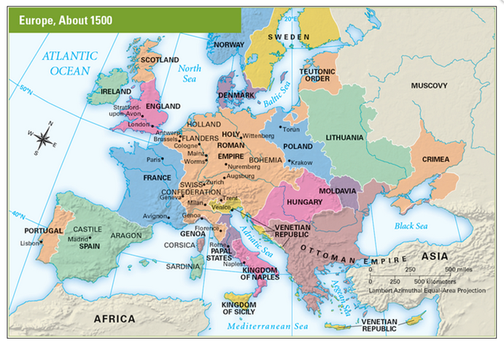

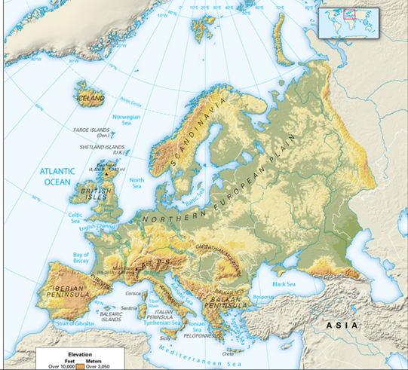
Geography Skills

Analyze the maps in the student text, then fill out the map as directed.

a. Locate the Holy Roman Empire. Outline it in green on your map.
b. Locate the Papal States. Outline them in red.
c. Use the blue pen tool to trace the Elbe River, Rhine River, and Danube River.
d. Locate the following cities, place a dot on the map for each location, and label them: Venice, Florence, Milan, ROme, Madrid, Paris, London, Worms, Wittenberg.

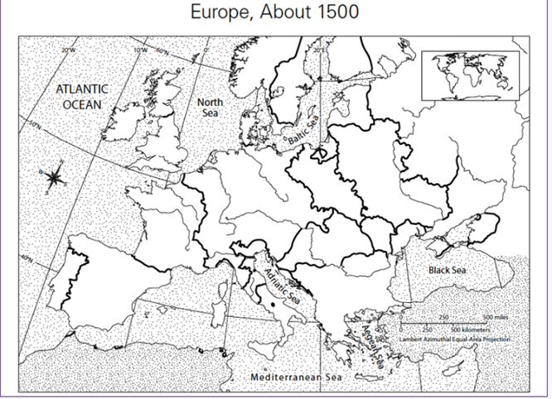
Using the map that you just labeled and the maps included with the text, answer the following questions.

Locate the following countries on your map: Spain, France, and England. Which of these is an island nation?

3
Locate the city of Avignon. In what country is it located?
4
The city-state of Venice is located on what body of water?
5
Based on location, which city in western Europe was most likely a center of trade with Africa and Asia? Why?
6
Locate the city of Wittenberg. A major religious movement began in Wittenberg and spread through Europe. What physical feature might have helped this movement spread from Wittenberg?
7
For centuries, the pope had been based in Rome. Then, in 1309, Pope Clement V moved the Roman Catholic Church to Avignon, France. Given the power of the Church at that time, how might this move have affected the relationship between the Church and the Papal States? Between the Church and the Italian city-states? How might it have affected France?

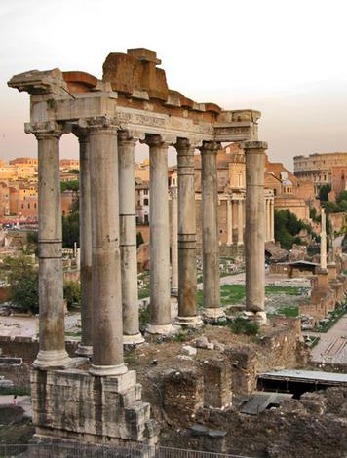Ruins left by the ancient Greeks and Romans inspired new interest in classical styles during the Renaissance.
Toward the end of the Middle Ages, a great flowering of culture called the Renaissance began in Italy. In this chapter, you will learn about the Renaissance and how it began.
Renaissance is a French word that means “rebirth.” Historians use the word to describe the rebirth of widespread interest in classical art and learning that took place in Europe from about 1300 to about 1600 C.E. “Classical” refers to the cultures of ancient Greece and Rome. Although there was no sudden end to the Middle Ages, the Renaissance changed many aspects of people’s lives over time.
Medieval European society was based on feudalism. Most people lived on feudal manors. The Roman Catholic Church encouraged people to think more about life after death than about daily life on Earth. Except for the clergy, few people were educated.
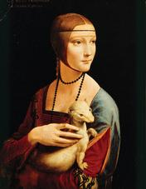Leonardo da Vinci's Lady with an Ermine reflects Renaissance ideas.
By the Late Middle Ages, changes were occurring that paved the way for the Renaissance. Trade and commerce increased. Cities grew larger and wealthier.Newly wealthy merchants and bankers supported the growth of arts and learning. A renewed interest in ancient cultures started a flood of new ideas. Greek and Roman examples inspired new styles of architecture, approaches to the arts, and ways of thinking.
Beginning in Italy, a philosophy called humanism developed. Humanists believed in the worth and potential of all individuals. They balanced religious faith with belief in the power of the mind. Humanists took a fresh interest in human society and the natural world. This thinking contributed to the burst of creativity during the Renaissance.
In this chapter, you will explore how the Renaissance differed from the Middle Ages and classical times. Then you will examine some changes in European life that led to the Renaissance.
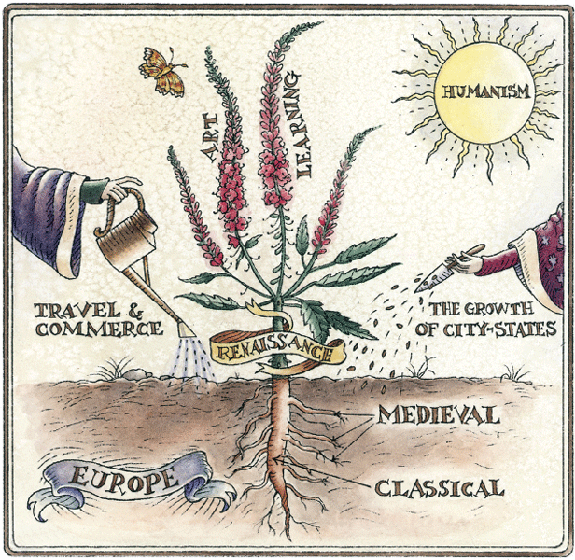Examine the diagram. In this “Renaissance plant,” which root grows straight up? Which roots branch out? What might this tell us about how the two time periods—medieval and classical—influenced the growth of the Renaissance?

- Plants need soil, sunlight, and water to grow. In the diagram, what three things seem to be contributing to the growth of the Renaissance?
3
- Why do you think that the soil is labeled “Europe”?
Renaissance began in Italy in the 1300s and spread to other parts of Europe in the 1400s and 1500s. Let’s look more closely at this “great rebirth” of interest in classical art and learning. Then we will explore the link between the Renaissance and the classical world.
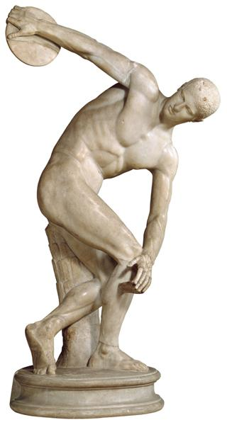This Roman copy of a Greek statue was created in 450 B.C.E. A discus thrower, it celebrates the classical ideals of athleticism, balance, and power.
Renewed Interest in the Classical World The Renaissance began with the rediscovery of the classical world of ancient Greece and Rome. After the fall of Rome in the 5th century C.E., classical culture was never entirely forgotten. Clergy of the Roman Catholic Church helped keep knowledge of ancient times alive by copying documents that survived from the classical period. Still, this knowledge reached relatively few people during most of the Middle Ages.
In the Late Middle Ages, merchants and Crusaders brought back goods and ideas from the East, including classical learning that had been preserved in the Byzantine Empire.Europeans also read classical works that came to them from Muslim scholars.
This flow of ideas led to a rediscovery of Greek and Roman culture. Scholars started collecting and reading ancient manuscripts from monasteries. Artists and architects studied classical statues and buildings. The renewed interest in classical culture led to the great flowering of art and learning that we call the Renaissance.
Exploring the Rebirth of Classical Ideas Through Art We can trace the link between the classical world and the Renaissance by looking at art. Let’s explore some of the characteristics of art from classical, medieval, and Renaissance times.
Classical Art The classical period lasted from about 500 B.C.E. to 500 C.E. The classical artists of Greece and Rome created sculptures, pottery, murals, and mosaics.The purpose of much of their art was to show the importance of ordinary people and civic leaders, as well as gods and goddesses. Here are additional characteristics of classical art:
• Artists valued balance and harmony.
• Figures were lifelike but often idealized, or more perfect than in real life.
• Figures were nude or draped in togas, or robes.
• Bodies looked active and motion was believable.
• Faces were calm and without emotion.
• Scenes showed either heroic figures or real people doing tasks from daily life.
• In paintings, there was little background or sense of perspective. Perspective is a visual technique used to make people and objects look closer or farther away and to give realistic depth to a scene.
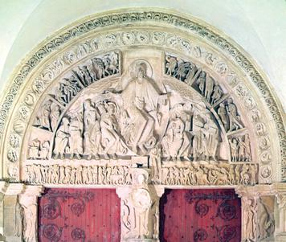This example of medieval art was created for a church in France in 1120 C.E. It shows Jesus sending his apostles out to preach.
Medieval Art The medieval period lasted from about 500 to about 1300 C.E.Medieval artists created stained glass windows, sculptures, illuminated manuscripts, paintings, and tapestries. The purpose of much medieval art was to teach religion to people who could not read or write. Here are additional characteristics of medieval art:
• Most art was religious, showing Jesus, saints, and people from the Bible.
• Important figures in paintings were shown larger than others around them.
• Figures looked stiff, with little sense of movement.
• Figures were fully dressed in stiff-looking clothing.
• Faces were serious and showed little expression.
• Painted figures looked two-dimensional, or flat.
• Paint colors were bright.
• Backgrounds were mostly one color, often blue or gold.
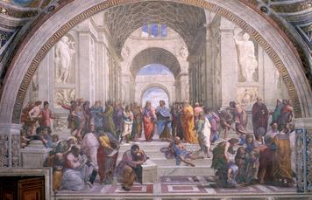This example of Renaissance art is titled The School of Athens. It was painted by the artist Raphael around 1510. Ancient Greek philosophers, such as Plato and Aristotle, are shown here, surrounded by some of the Renaissance artists they later inspired.
Renaissance Art The Renaissance lasted from the 1300s to the early 1600s.Artists created sculptures, murals, drawings, and paintings. The aim of much Renaissance art was to show the importance of people and nature, not just religious ideas. Artists also began using new techniques. Here are additional characteristics of Renaissance art:
• Artists showed religious and nonreligious scenes.
• Art reflected a great interest in nature.
• Figures looked lifelike and three-dimensional, reflecting an increasing knowledge of anatomy.
• Figures were shown in action.
• Figures were either nude or clothed.
• Scenes showed real people doing everyday tasks.
• Faces expressed what people were feeling.
• Colors were shown responding to light.
• Paintings were often symmetrical, or balanced, with the right and left sides having identical elements.
• Full backgrounds showed perspective, adding depth.
If you compare these three styles, you can see that Renaissance artists were inspired more by classical art than medieval art. Like classical artists, Renaissance painters and sculptors depicted subjects that were not always religious. They tried to show people as lifelike and engaged in everyday activities. They also tried to capture the way things look in the real world.
Renaissance art reflects a rebirth of interest in the classical world. What changes brought about this revival of classical culture?

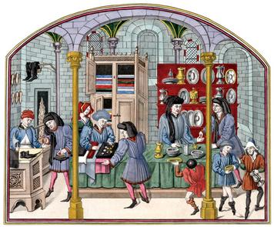One reason for the flowering of culture during the Renaissance was the growth of trade and commerce. Trade brought new ideas as well as goods into Europe. A bustling economy created prosperous cities and new classes of people who had the wealth to support art and learning.
Increased Contact Between East and West Starting in the 11th century, the Crusades strengthened contacts between western Europe and Byzantine and Muslim cultures. Merchants brought goods and ideas from the East that helped to reawaken interest in classical culture. In the 13th century, the Mongol conquests in Asia made it safer for traders to travel along the Silk Road to China. The tales of the Italian traveler Marco Polo sparked even greater interest in the East. Food, art, and luxury goods, such as silk and spices, moved along the trade routes linking Europe to Africa and Asia.
Cities, such as Venice and Genoa in Italy, were centrally located on the trade routes that linked the rest of western Europe with the East.They became bustling, prosperous trading centers that attracted merchants and customers, as did cities in northern Europe, such as Bruges and Brussels. Trade ships carried goods to England, Scandinavia, and present-day Russia by way of the English Channel and the Baltic and North seas. Towns along the routes connecting southern and northern Europe, such as Cologne and Mainz in Germany, provided inns and other services for traveling merchants.
A New Economy The increase in trade led to a new kind of economy. During the Middle Ages, people bartered, or traded, goods. By the Renaissance, people were using coins to buy merchandise, creating a money economy. Coins came from many places, so money changers were needed to convert one type of currency into another.
As a result of all this activity, craftspeople, merchants, and bankers became more important in society. Craftspeople produced goods that merchants traded across Europe. Bankers exchanged currency, loaned money to merchants and rulers, and financed their own businesses.
Some merchants and bankers grew very rich. With their abundant wealth, they could afford to make their cities more beautiful. Wealthy patrons commissioned (ordered and paid for) new buildings and art. They also helped to found universities. Prosperous Renaissance cities grew into flourishing educational and cultural centers.

- Describe how Marco Polo’s travels along the Silk Road helped reawaken interest in classical culture.

- List and explain two results of the increase in trade in Europe.

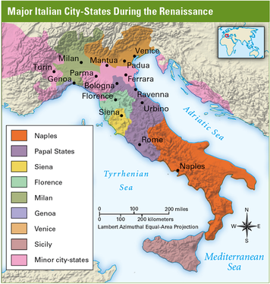At the time of the Renaissance, Italy was not a unified nation. It was divided into many different city-states, some of which were extremely powerful.
The Renaissance began in northern and central Italy. One reason why it began there was the prosperity of Italian city-states.
In the Late Middle Ages, most of western Europe was made up of fiefs ruled by nobles. Above the nobles were monarchs. In Italy, however, growing towns developed into independent city-states. Each city-state consisted of a powerful city and the surrounding territory, which might include other towns.
The Italian city-states conducted their own trade, collected their own taxes, and made their own laws. Some, such as Florence, were republics that were governed by elected councils.
In theory, the power in republics belonged to the people. In fact, it often lay in the hands of rich merchants. During the Middle Ages, guilds of craftspeople and merchants became very powerful. During the Renaissance, groups of guild members, called boards, often ruled Italian city-states. Boards were supposed to change members frequently. However, wealthy families often gained long-term control. As a result, some city-states were ruled by a single rich family, such as the Medici (MED-uh-chee) family in Florence.
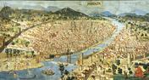
Click to read caption
Trade made the Italian city-states dazzlingly wealthy. Italy’s central Mediterranean location in the middle of the trade routes connected distant places with the rest of western Europe. People from all over Europe came to northern Italy to buy, sell, and do their banking.
Some Italian city-states developed specializations. Florence became a center for cloth making and banking.Milan produced metal goods and armor. The port city of Genoa was a trade center for ivory and gold from northern Africa. Venice, the most powerful city-state, had hundreds of ships that controlled the trade routes in the Mediterranean Sea. Silk, spices, and perfume from Asia flowed into Venice.
The city-states’ wealth encouraged a boom in art and learning. Rich families paid for the creation of statues, paintings, beautiful buildings, and elegant avenues. They built new centers of learning, such as universities and hospitals. From the city-states of Italy, Renaissance ideas spread to the rest of Europe.

- What were Italian city-states? How were they governed?
2
- How did Italian city-states become so powerful?

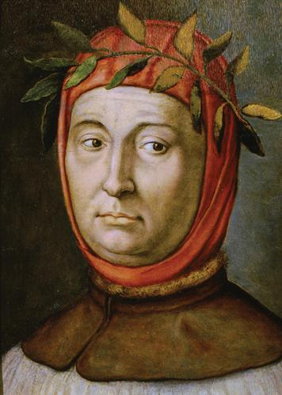Francesco Petrarch is considered to be the founder of Italian Renaissance humanism. A well-known poet, he wears a laurel wreath in this portrait to symbolize his crowning as poet laureate in Rome in 1341.
The interest in learning during the Renaissance was spurred on by humanism.This way of thinking sought to balance religious faith with an emphasis on individual dignity and an interest in nature and human society.
Humanism first arose in Italy as a result of the renewed interest in classical culture.Many early humanists eagerly hunted for ancient Greek and Roman books, coins, and other artifacts that could help them learn about the classical world.
One of the first humanists was an Italian poet named Francesco Petrarch. Petrarch especially loved old books. He searched for them all over Europe and encouraged his friends to bring him any they found. Eventually, he created a large collection of ancient Latin and Greek texts, which he made available to other scholars.
Scholars from all over Europe traveled to Italy to learn about the new humanist ideas inspired by classical culture. They studied such subjects as art, architecture, government, and language. They read classical history and poetry. They began to ask probing questions. What did classical artists find most beautiful about the human body? How did the Romans construct their buildings?
In their studies of classical culture, humanists discovered a new way of looking at life. They began to create a philosophy based on the importance and dignity of each individual. Humanists believed that all people have the ability to control their own lives and achieve greatness. In education, they stressed study of thehumanities—a group of subjects that focus on human life and culture. These subjects include grammar, rhetoric (the study of persuasive language), history, poetry, and ethics (the study of moral values and behavior).
Humanists tried to put ancient ideas into practice. Architects, for example, studied Greek and Roman ruins. They designed buildings with pillars, arches, and courtyards like those of classical buildings.
The humanists did not simply imitate classical achievements. They tried to improve on the work of the ancient Greeks and Romans. In universities, scholars began to teach methods of observation and experimentation. Renaissance scientists proposed new ideas about the stars and planets. Artists and students of medicine closely studied human anatomy. Poets wrote about both religious subjects and everyday experiences. Writers produced works of history and studies of politics.
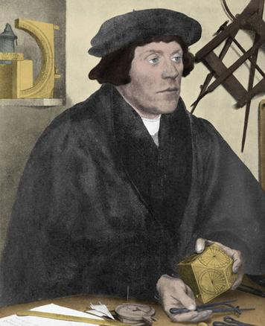Humanist scholars in the Renaissance spent time reading, studying, and writing about classical culture.
The influence of classical ideals changed ideas about government. Humanists separated the state and its right to rule from the Church. In doing so, they helped lay the foundation for modern thinking about politics and government.
Humanist ideals also changed people’s thinking about social standing. In feudal times, people were born into a certain status in society. If someone was born a peasant, he or she would always have less status than a noble. In general, Renaissance thinkers prized individual achievement more than a person’s class or family. This emphasis on individualism was an enormous shift from medieval thinking.
The humanists’ new ideas sometimes brought them into conflict with the Catholic Church. The Church taught that laws were made by God and that those who broke them were sinful. It encouraged people to follow its teachings without question to save their souls. For the Church, life after death was more important than life on Earth. In contrast, humanists believed that people should use their minds to question everything. Most tried to balance religious faith and its emphasis on the afterlife with an active interest in daily life. Some directly challenged teachings that were important to the Church. An Italian humanist, Giordano Bruno, paid for his ideas by being burned at the stake.

- What did Renaissance humanists believe about people’s abilities?

- What subjects from ancient times did humanists study and explore?

- How did the Renaissance humanists’ beliefs sometimes conflict with those of the Catholic Church?

