SONG DYNASTY (960-1279)
Song history is divided into two periods, Northern and Southern Song. Under the Northern Song, the military lost prestige. Unfortunately, the weakening of the military coincided with the rise of strong nomadic nations on China's borders. The Song were forced by nomadic invaders to abandon north China in 1127. The Southern Song settled at Hangzhou and ruled south of the Huai River.
Though politically weak, the Southern Song ruled over a time of philosophical and intellectual initiative and technological creations. Education spread. The Song period was noted for its historical writings, landscape painting, calligraphy, and hard-glazed porcelain. Cities developed as centers of trade, industry, and maritime commerce. A new mercantile class arose, made up of wealthy commoners. But urbanization brought about a decline in the status of women in the upper classes. Women's work was now less essential than it had been in rural areas. The practices of concubinage and of binding girls' feet took root. The Song staffed their centralized bureaucracy with civilian scholar-officials, and military governors were replaced by appointed officials. These moves gave greater power to the emperor. While the Southern Song ruling class and many city residents enjoyed a luxurious life, there was widespread poverty. People in the countryside had to deal with absentee landlordism. Then the great nomad empire in the north, the Mongols, descended on the Southern Song.
- Introduction
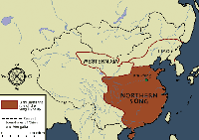
In political terms, the fall of the Tang Dynasty (681-907) and the resultant disintegration of the empire did not mean a sharp break with the past.
The Five Dynasties all aspired to the reunification of China and by 959 the Later Zhou had brought much of the country back under a single ruler.
The changes of dynasty were due to the change of ruling family. The ruling elite remained unaltered and the civil service continued the routine tasks of government with no serious disruption
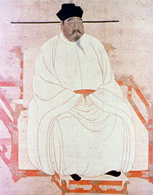
In the south in several of the Ten States the same continuity was evident and the examination system continued. When Zhao Kuangyin seized power by a coup in Chenqiaoyi in 960 he was able to consolidate and extend his control in a restrained and methodical manner.
The Song Dynasty that he founded has been divided into two periods. Firstly, the Northern Song when the capital was in Dongjing (present day Kaifeng City in Henna Province) from 960 to 1127.
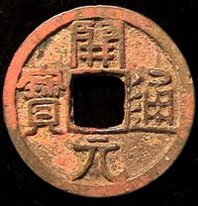
Secondly, the Southern Song, with their capital in present day Hangzhou from 1127 to 1279.
With all of these achievements it's no wonder that so many people flock to visit China nowadays. Many people choose to skip on hotel deals NYC has to offer and are passing up cheap Caribbean vacation packages in favor of taking a more fulfilling cultural trip to China.
The Song Dynasty ranks alongside the Tang and also the Han (206 BC - 220 AD) in importance. For a little under three and a quarter centuries under its rule, China enjoyed a period of economic growth coupled with great artistic and intellectual achievement.
It has been said that song was referred as the Renaissance of Chinese which compared to Europe’s Renaissance. It is a great period in China’s history.

The Elm Tree Palisades: The Great Wall of the Northern Song
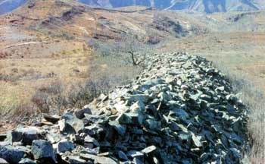
Fig. 1 Remains of Tang dynasty Great Walls in Chicheng county, Hebei province.
Within China's annals of more than two and a half millennia of building Great Wall defensive systems, the Song dynasty (Northern, 960-1127 and Southern, 1127-1279) is regarded as one of the very few ruling polities, like the Tang, that did not engage in the construction of some form of defensive barricades along its northern borders. But the Tang did build walls (Fig. 1), and the Song, as shown in a recently published article, had their own approach to the need to barricade themselves from any potential enemy threatening their settled way of life.
The Song dynasty is remembered today for its material culture and literature which preserve an image of genteel living and refined taste. In philosophy, the Song saw a resurgence of the examination system, intellectual enquiry and the emergence of a new sobriety, in which religious and secular ideas attained balance and synthesis. This was encapsulated in what later came to be called Neo-Confucian thought. Buddhism, Daoism and popular religion also flourished in this general atmosphere of dedication, idealism and tolerance. The visual arts of the Song dynasty captured the new balance and restraint. Painting and calligraphy attained unprecedented subtlety by dint of imperial patronage, exemplified by that of the artist and emperor Zhao Ji, better known by his temple name of Song Huizong (r. 1101-1125). The taste of the period is perhaps best expressed through the fine porcelain produced by kilns in the north and, later, the south. During the Northern Song, one of the most renowned of these was the Ding Kiln, located in Dingzhou, Hebei province, not far from the Northern Song capital. (Fig. 2 ) Despite the high quality of the wares, there was mass production of some items, and ceramics became an everyday commodity for the first time in Chinese history.
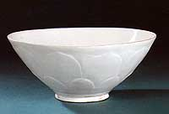
Fig. 2 Thin-bodied Ding kiln bowl with lotus petal pattern
Height: 8.2cm
Unearthed in 1969 from the crypt of the pagoda at Jingzhi-si [temple], Dingzhou, Hebei province. Now in the collection of the Dingzhou Municipal Museum.
The Song dynasty emerged from the division of the Five Dynasties period (907-960) to weather successfully a simmering threat from the north for a century and a half from the time of its founding by Zhao Kuangyin (927-976). And, from the outset, the Song was no stranger to warfare. The founder of the Song dynasty never succeeded in bringing all of what had been China in the heyday of the Tang dynasty under his control. He brokered a precarious peace with the vast Liao state to the north established by the Khitan as early as 907. Prior to the founding of the Song, the Khitan rulers were receiving tribute from the Tibetans (Tubo), Tuyuhun, the pre-dynastic Tanguts, the Uyghur tribes and Arslan Turks, and they were close allies with the short-lived Latter Jin dynasty until they vanquished it in 946. In the first half of the 11th century, the Tanguts, an ethnic group that later converted to Tibetan Buddhism, established the Xixia or Western Xia dynasty centred on Ningxia and Inner Mongolia. With its northern hinterland crowded with the polities of different ethnic groupings gradually converging towards an agricultural—and dynastic—lifestyle, the Song oriented itself towards the south. Ironically, it was the Liao dynasty of the Khitan, not the Song, who resumed the Chinese perennial practice of building Great Walls of heavy masonry, as well as extensive trench systems, in the north.
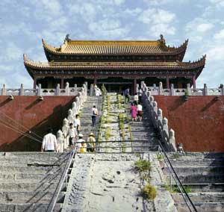
Fig. 3 Longting (Dragon Pavilion) built on the site of the audience hall in the grounds of the Imperial City in the Northern Song capital, Bianliang (present-day Kaifeng).
The territory of the Northern Song was limited to the Central Plains area, and did not extend much further north than the parallel of today's Tianjin. Zhao Kuangyin, the first Song emperor whose posthumous title was Song Taizu (r. 960-975), established his capital in Bianliang (Kaifeng), although today there are few remains of, but many monuments to, the Song period in that city. In what was once the Imperial City or the walled palace precincts of Song Bianliang, on the site of an imperial audience hall today there stands the Longting, or Dragon Pavilion. (Fig. 3) But it is a Qing structure built in 1692 by the Kangxi Emperor and it now houses a bargain basement waxwork 'likeness' of Zhao Kuangyin.

The Military Face of the Song Dynasty
Zhao Kuangyin was a skilled soldier, but the Song is not thought of today as a 'martial' dynasty. This impression is not only attributable to our appreciation of the refinement of its culture, but also to the fact that its government was effected through civilian administrators rather than regional military governors, as had been the case with the majority of preceding polities. However, in the Song dynasty, traditional combat weapons, referred to in Chinese military histories as 'cold weapons' (leng bingqi), reached the apogee of their development. The manufacture of firearms, or rather of weapons making use of gunpowder, also began in the Song. One of the priorities of the Song when establishing its capital in Bianliang was setting up large arsenals there under the direct control of the central government.
Information concerning the weapons, military institutions and strategic philosophies of the Song dynasty is best obtained from a mid-11th century work titled Wujing zongyao (The essentials of military classics). The work was compiled by Zeng Gongliang (998-1078) and Ding Du (990-1053) in response to an imperial edict of Emperor Renzong (r. 1023-1063). The work comprises two sections, totalling 40 fascicles, and its illustrations have proved invaluable for later military historians. The original Song edition was lost, and the earliest we have dates from the years between the Hongzhi and Zhengde reigns, specifically between 1438 and 1521, and it was based on a Southern Song edition. In 1959, the prestigious academic publishing house Zhonghua Shuju photo-lithographed this edition, which was in the possession of scholar and bibliophile Zheng Zhenduo (see China Heritage Newsletter #4, Articles, 'Shaping the Forbidden City as an Art-Historical Museum in the 1950s'), and a reproduction of that work was also included in the collection titled Zhongguo gudai banhua congkan (The collection of ancient Chinese wood-block printed works), published by Shanghai Ancient Books Publishing House in four volumes in 1988.

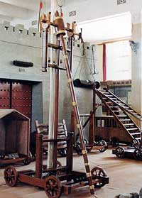
Fig. 4 Photograph of a replica of a Song dynasty siege engine (paoshiji or paoche, ballista) from the Beijing Military Museum. (Source: Lu Xixing ed., Zhongguo gudai qiwu dacidian: bingqi, xingju [Comprehensive dictionary of ancient Chinese artefacts: Weapons and instruments of punishment], Shijiazhuang: Hebei Jiaoyu Chubanshe, 2004.)
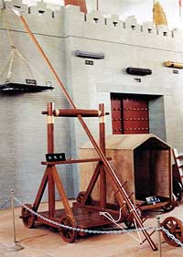
Fig. 5 Photograph of replicas of two Song dynasty siege engines from the Beijing Military Museum. Left: eche or eguche, lit. 'swan-goose wagon' or 'pecking machine', designed to harass defenders on the top of walls. Right: fenyunche or fenwenche, a low armoured vehicle covered with fresh hide to prevent arrows penetrating, which could be pushed up against the base of fortified walls, while providing cover for moving materials or bringing in reinforcements of up to ten persons laying siege. (Source: as above.)

The illustrations in this ancient military encyclopaedia reveal the high level attained by Song dynasty military inventors, designers and craftsmen, and the importance attached by the Song to weapons manufacture. The cold weaponry it includes and describes remained largely unchanged down to the Qing dynasty. Moreover, siege warfare and siege machinery are documented in great detail, indicating the great advances made by the Song in this area. The mastery of the many siege engines, such as the paoche, fenyunche and eguche, (Figs. 4 and 5) [Elm05.jpg & Elm06.jpg] described in this work would have made the Song armies a potentially formidable besieging force.

The Song Dynasty under Siege and its Walls
The Song armies were not, however, prone to laying siege. The Song dynasty was itself under siege. The final collapse of the Song before invading Jurchen armies was preceded by a steady retreat, albeit diplomatic. The failure of barricades to hold back the enemy does not play a part in the Song demise as it is conventionally related in history books, to the extent that the Manchu advance into the Central Plains is described euphemistically as the entry through Shanhaiguan Pass of the Manchu armies. For this reason, the Song has never been regarded as a dynasty that built barriers like the Ming Great Walls to protect itself. Yet, in fact, as we will see below, there are many parallels in the way the defences these two dynasties put in place were sidestepped in the course of their fall.
The Northern Song dynasty is not regarded as a dynasty that constructed defensive long walls, trench emplacements or barriers, unlike the rival Liao and Jin dynasties to their north. However, in an article published in the May 2006 issue of Inner Mongolia Social Sciences, Tao Yukun, an historian at Inner Mongolia Normal University, puts paid to that view. She shows, convincingly, that in the 11th century the rulers of the Northern Song drew on aspects of the long-standing defensive policies formulated by China's rulers of the Qin and Han dynasties, of erecting walls and barriers to prevent the southern incursion of peoples inhabiting the vast Eurasian steppe. But, as Tao describes, the 11th century Song dynasty's Ministry of Defence implemented a 'green belt' defensive policy that took the form of 'elm tree palisades' (yusai), a sustainable, living 'Great Wall' that would have partly offset environmental degradation in northern China.

The Great Walls of Elm
The stand-off between the Song dynasty and the northern nomadic pastoral peoples began in the mid-11th century. The encroachment of the proclaimed Liao dynasty of the Khitan people into northern China was signalled by its occupation of the Sixteen Prefectures of Yan-Yun, including present day Beijing and northern Hebei. The area the Khitan then controlled extended south of the line of earlier Great Walls first delineated by the Yan state and Qin and Han dynasties in the third and second centuries BCE. As a result of Khitan advances, the border between the Liao and Song ran in a line from the Baigouhe River in the east, and extended, at the centre, through today's northern Hebei and central Shanxi provinces. The area of the North China Plain, to the east of the Taihang Mountains, was vulnerable Song territory, and the plains lacked topographical features that lent themselves to the easy construction of forts, such as those that commanded mountain passes to the north. To defend itself in the face of escalating territorial threat, the Song government constructed a series of connected ponds and lakes (called tangbo) running from Baozhou (present day Baoding) in the west to Cangzhou in the east. The administrative centre or zhisuo of Song dynasty Cangzhou was in present day Cangxian county, Hebei province. The network of lakes was designed to thwart the Liao cavalry, against whom the Song also had recourse to primitive non-explosive landmines and spiked obstacles named for their shape 'puncture vines' (jili or Tribulus terrestris).
The lines of natural and man-made lakes were unfortunately seasonal and they either froze over in winter, enabling the Khitan horsemen to cross, or they dried up in the late autumn or early spring. The lakes were therefore supplemented by a dense network of trees, which were called 'the elm palisades' (yusai). The extent to which the Chinese or lacework elm (Ulmus parvifolia), as opposed to other varieties of trees, was planted to form the palisades cannot be ascertained from the brief historical records of this defensive experiment in reforestation. However, there is a reference in Song huiyao jigao (The compiled manuscripts containing important documents of the Song), cited by Tao Yukun, to an order issued by Emperor Shenzong in 1072 to plant 'mulberries, dates, elms and willows' on the northern frontier between Cangzhou and the Liao.
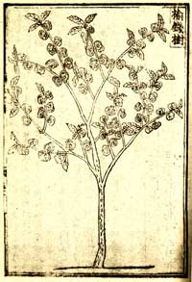
Fig. 6 Illustration of lacework elm tree (yushu or yuqianshu) from a Ming edition of the pharmacopoeia titled Jiuhuang bencao (Pharmacopoeia for relieving years of plight), dated 1525.
The lacework elm has many uses, and its leaves, bark and other parts are included in many Chinese pharmacopoeias. (Fig. 6) [Elm02.jpg] Moreover, it is a hardy native of the harsh climate of north China and it does well in poor soil, whether sand, clay and loam. In recent years lacework elm trees have been planted in areas of Inner Mongolia in an attempt to halt desertification, and it is being introduced, on an experimental basis, as a street-side shade tree in parts of the USA because it is free from Dutch elm disease. It grows up to 18m in height and, when closely planted, its broad pendulous branches form thickets that would be difficult for cavalry to penetrate.
Elm trees were planted along the borders of the Song dynasty's Hebei 'Lu' or 'circuit', the political division equivalent to a contemporary province. The elm palisades were planted between the lakes and ponds; they were also planted on all high ground, along official roads and around settlements. To the west in the Taihang Mountains, the terrain that formed the borders between the Song dynasty's Hedong Lu and the Liao domains was high wooded ground, and here the Song issued orders that forests be conserved, effectively forming a second tier of 'elm palisades'. However, because of the paucity of relevant historical documentation, we have little detailed information today about the full extent of the elm palisades of the Song.

Later Policy Reversal
In adopting this policy of planting and using existing forests for defence, the Song military policy-makers were emulating what little was known of an aspect of Qin-Han defence strategies mentioned only in passing reference to Meng Tian in Han shu and other early texts, but cited as a precedent by Song defence policy officials. The policy of protecting forests to defend the state's borders and the ban on tree-felling created unemployment in some places and resulted in a shortage of firewood. Concerned by this situation, Han Qi, a military official from the Dingzhou Lu alerted the throne to the problem in a memorial of 1049: 'The court has banned the felling of trees in areas adjacent to the borders in order to obstruct the entry of barbarians and marauders into this circuit. A blanket ban was also implemented at that time on land clearance for farming in the low hilly areas near villages, and this resulted in many of the inhabitants of the borderlands suddenly losing any means of employ. Now the price of firewood and fuel has soared, and the policy has had the inverse effect of enabling the enemy to reap enormous profits from our shortfall. I have sent out inspectors to determine in which areas these bans should be applied and believe that a shelter belt between us and the enemy of fifty or sixty li is sufficiently wide to ensure our defence. So I have redrawn the boundaries where the bans apply and have issued a proclamation allowing timber felling in the areas where bans are felt to be no longer necessary'. This would seem to be a reversal of an earlier ordinance issued by Han Qi himself not permitting any tree-felling north of Dingzhou.

Environmental Protection
This defensive policy of enhancing and protecting forests also served to protect the environment of northern China. In his study of changes in the vegetation cover of north China, Zhu Shiguang pointed out that in the historical period most depletion of the tree cover in the region resulted from human agency. However, in his discussion of the entire period of more than two and a half millennia from the Western Zhou to the Qing dynasty, he omitted the Song, Liao and Jin dynasties from his discussion. Tao Yukun believes that the Song policy may have reversed this general historical trend, even if only for a short time.
By the time of the Xining reign period (1068-1077), the Liao was demanding that the Song redraw the boundaries of Hedong Lu. The Song resolved to strengthen their borders and augment the 'elm palisades', establishing an office in 1073 under Huo Shunfeng to oversee them, but in 1078 Huo was dismissed and the initiative came to nought. The palisades aroused the ire of the Liao, who covertly and overtly despatched axmen to fell the trees. However, a way through the elm thickets facilitating the passage of cavalry travelling in more than single file was finally cut by the Northern Song official Tong Guan (1054-1126). In an attempt to form an alliance with the Jurchen (Jin dynasty) against the Khitan's Liao dynasty, he launched an attack along the corridors he felled through the elm palisades and attempted to recover the Yan-Yun prefectures. He was unsuccessful in battling the Liao, and sought help from the Jin, who occupied Yanjing (Beijing) in his stead. The Jin honoured Tong Guan for his contribution to their victory and appointed him prince of Guangyang. In 1125, Tong was in Taiyuan, when he heard the news that the Jin troops had made the most of the opportunity he extended to them and had conquered the Northern Song capital Bianliang. Tong Guan rushed south to join the Song emperor Huizong who was preparing to flee to southern China, but, for his part in the collapse of the Northern Song and Huizong's subsequent death, Tong was sentenced to death by Emperor Huizong's successor Qinzong, who reigned for the final year of the Northern Song. For Tong Guan, and the Song, the proverbial Birnam Wood to Dunsinane had come. [BGD]

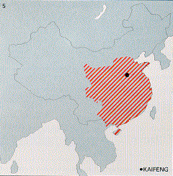
But in 960 a new power, Song (960-1279), reunified most of China Proper. The Song period divides into two phases: Northern Song (960-1127) and Southern Song (1127-1279). The division was caused by the forced abandonment of north China in 1127 by the Song court, which could not push back the nomadic invaders.
The founders of the Song dynasty built an effective centralized bureaucracy staffed with civilian scholar-officials. Regional military governors and their supporters were replaced by centrally appointed officials. This system of civilian rule led to a greater concentration of power in the emperor and his palace bureaucracy than had been achieved in the previous dynasties.
The Song dynasty is notable for the development of cities not only for administrative purposes but also as centers of trade, industry, and maritime commerce. The landed scholar-officials, sometimes collectively referred to as the gentry, lived in the provincial centers alongside the shopkeepers, artisans, and merchants. A new group of wealthy commoners--the mercantile class--arose as printing and education spread, private trade grew, and a market economy began to link the coastal provinces and the interior. Landholding and government employment were no longer the only means of gaining wealth and prestige.
Culturally, the Song refined many of the developments of the previous centuries. Included in these refinements were not only the Tang ideal of the universal man, who combined the qualities of scholar, poet, painter, and statesman, but also historical writings, painting, calligraphy, and hard-glazed porcelain. Song intellectuals sought answers to all philosophical and political questions in the Confucian Classics. This renewed interest in the Confucian ideals and society of ancient times coincided with the decline of Buddhism, which the Chinese regarded as foreign and offering few practical guidelines for the solution of political and other mundane problems.
The Song Neo-Confucian philosophers, finding a certain purity in the originality of the ancient classical texts, wrote commentaries on them. The most influential of these philosophers was Zhu Xi ( b1130-1200), whose synthesis of Confucian thought and Buddhist, Taoist, and other ideas became the official imperial ideology from late Song times to the late nineteenth century. As incorporated into the examination system, Zhu Xi's philosophy evolved into a rigid official creed, which stressed the one-sided obligations of obedience and compliance of subject to ruler, child to father, wife to husband, and younger brother to elder brother. The effect was to inhibit the societal development of premodern China, resulting both in many generations of political, social, and spiritual stability and in a slowness of cultural and institutional change up to the nineteenth century. Neo-Confucian doctrines also came to play the dominant role in the intellectual life of Korea, Vietnam, and Japan.

Song Dynasty
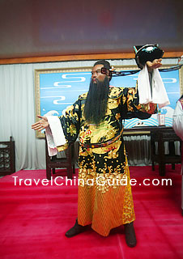
Wax statue of Lord Bao,
an upright official in the
Northern Song Dynasty
Starting in 960 and ending in 1279, the Song Dynasty consisted of the Northern Song (960-1127) and the Southern Song (1127-1279). With a prosperous economy and radiant culture, the Song Dynasty was considered as another period of 'golden age' after the glorious Tang Dynasty (618 - 907).
The Northern Song was founded by Zhao Kuangyin, a military general in the Latter Zhou (951 - 960). In 960, Zhao Kuangyin launched a mutiny in Chenqiao county (in current Henan Province).It was not long before the last king of the Latter Zhou was forced to abdicate. Thus a new dynasty - Song Dynasty was established in Kaifeng. In that period, most part of China's territory was unified. However, in late Northern Song, the political corruption was serious and the regime began to decline. In 1127, the Northern Song was destroyed by the Jin (1115 - 1234).
The Southern Song was set up by Zhao Gou, son of the last emperor of Northern Song. After Jin defeated the Northern Song, many imperial clansmen were captured by Jin's army. Fortunately, Zhao Gou had a luck escape. In 1127, he fled to Nanjing Yingtianfu (in current Shangqiu of Henan Province) and established the Southern Song Dynasty there. Later, the capital city was moved to Lin'an (currently Hangzhou City in Zhejiang Province).The Southern Song's regime was subject to the Jin. Many patriotic generals were killed in the late period. In 1279, the army of the Yuan Dynasty captured Lin'an, putting the Southern Song to an end.
Generally, the Song Dynasty was prosperous in many respects of the society. In agriculture, the productive technology was improved which promoted the output of food; in handicraft industry, the division of labor became more detailed which made the handicrafts technology reach an advanced level; additionally, the development of the commodity economy exceeded the previous level. Particularly, the earliest paper currency appeared at that period.
As for the development of science and culture, tremendous achievements were made in the Song Dynasty. Two of China's four great inventions - typography and compass were both invented and the application of gunpowder also developed rapidly. With regard to literature, a large number of outstanding scholars and poets, such as Zhuxi, Ouyang Xiu, Su Shi, Sima Guang and Shen Kuo, emerged and built up the splendid cultural atmosphere of the Song Dynasty.
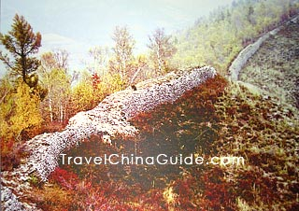  Ruins of Song Great Wall  in Kelan County, Shanxi | Xiangguo Temple,  a Buddhist Temple in Kaifeng
Emperors of the Song Dynasty
Order |  | Name | Notes |  | Reign Time (years)
Northern Song (960 - 1127)
1 | Song Taizu  (Zhao Kuangyin) |  | Formerly the leading general of the Latter Zhou (951 - 960); He usurped the throne and founded the Song Dynasty by launching a coup. | 960 - 976
2 | Song Taizong  (Zhao Guangyi) |  | The younger brother of Zhao Kuangyin; during his reign, the whole China was unified by his defeating the Northern Han (951 - 979). | 976 - 997
3 | Song Zhenzong  (Zhao Heng) |  | Son of Emperor Taizong; In his reign, the military power of Song was strengthened but he signed the first humiliating treaty with the Liao (916 - 1125). Especially, he founded the famous ceramic kiln in Jingdezhen. | 997 - 1022
4 | Song Renzong  (Zhao Zhen) |  | Son of Emperor Zhenzong; His reign was the turning point of the Song Dynasty from the prosperity to the disintegration. | 1022 - 1063
5 | Song Yingzong  (Zhao Shu) |  | Son of one of the imperial clansmen and was adopted by Emperor Renzong; Actually, Emperor Yingzong's father was the first cousin of Emperor Renzong. | 1063 - 1067
6 | Song Shenzong  (Zhao Xu1) |  | During his reign, he appointed Wang Anshi as Chancellor who presented a series of reform policy. He tried to expel Xixia (a contemporary kingdom of the Northern Song) troops out of the Song's territory but it was in vain. | 1067 - 1085
7 | Song Zhezong  (Zhao Xu3) |  | Son of Emperor Zhenzong; In his reign, a conventional chancellor named Sima Guang was appointed, who once halted the reform policy put forth by Wang Anshi. | 1085 - 1100
8 | Song Huizong  (Zhao Ji) |  | The 11th son of Emperor Shenzong; one of the few monarchs who favored Taoism and against Buddhism; As an emperor, he was more well-known as a painter, poet, calligrapher and musician. | 1100 - 1125
9 | Song Qinzong  (Zhao Huan) |  | The eldest son of Emperor Huizong; He ascended to the throne after his father abdicated. However, the Song court was defeated by the Jin army in 1127 after which both Qinzong and Huizong were demoted to commoner. | 1126 - 1127
Southern Song (1127 - 1279)
10 | Song Gaozong  (Zhao Gou) |  | The ninth son of Emperor Huizong who escaped the capture of the Jin court; He founded the weak Northern Song in Lin'an (currently Hangzhou). | 1127 - 1162
11 | Song Xiaozong  (Zhao Shen) |  | He belonged to the seventh generation descendants of Emperor Taizu. | 1162 - 1189
12 | Song Guangzong  (Zhao Dun) |  | The present Chongqing City was originally named by Guangzong, meaning ‘double celebration'. | 1189 - 1194
13 | Song Ningzong  (Zhao Kuo) |  | In his reign, the cultural and intellectual achievements were abundant. | 1194 - 1224
14 | Song Lizong  (Zhao Yun) |  | He was not interested in state affairs. In his reign, the Jin (1115 - 1234) was destroyed in 1234. | 1224 - 1264
15 | Song Duzong  (Zhao Qi) |  | Nephew of Emperor Lizong; His reign was full of rebellions and war affairs. | 1264 - 1274
16 | Song Gongdi  (Zhao Xian) |  | Son of Emperor Duzong; His reign lasted for only two years then he abdicated to his elder brother. | 1275 - 1276
17 | Song Duanzong  (Zhao Shi) |  | Son of Emperor Duzong; His reign also lasted for two years till his death. | 1276 - 1278
18 | Song Weiwang  (Zhao Bing) |  | Younger brother of Duanzong and died at eight; Chancellor Lu Xiu carried him jumping into the sea after the Yuan army's invasion. | 1278 - 1279
Establishment
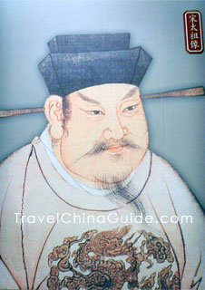
Zhao Kuangyin,
the first emperor
of Northern Song Dynasty
In 960, a military general of the Latter Zhou Dynasty (951 - 960) named Zhao Kuangyin launched a mutiny in Chenqiao County. After forcing the last emperor of the Latter Zhou to yield the throne, he established the Northern Song in Kaifeng (the provincial capital of Henan Province). Zhao Kuangyin became Emperor Taizu, the first emperor of the Song Dynasty. In the first two decades, Emperor Taizu and his brother Emperor Taizong put down the chaos of the ten states and unified most of the territory of China.
Development
In the early Northern Song, society and politics were both stable. Soon after the founding of the new dynasty, Emperor Taizu removed military power from the hands of the Jiedushi (regional military governors) consolidating the military leadership and placing it under the control of the emperor. From then on, a rather centralized state power was formed. Due to the policy of 'viewing literacy as more important than the military', a class of civil officials including some eminent poets, such as Su Dongpo and Fan Zhongyan were appointed in the court. During the reign of Emperor Renzong, the economic and social development reached the zenith.
Science and Culture
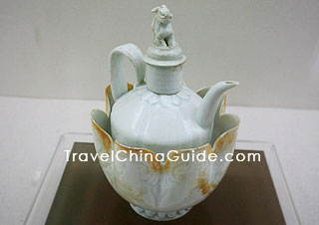
Porcelain, Northern Song Dynasty
To some extent, the development of science, culture, and art in the Northern Song was as advanced as that of the Tang Dynasty (618 - 907). In science, the world's earliest typography was invented by a man named Bi Sheng. In addition, gunpowder was first applied to military affairs. As for literature, the 'ci' poem, a new expressive form of Chinese ancient literature, became another gem of Chinese ancient culture along with Tang poetry. In the arts, the painting of the Northern Song reached a very high artistic level. The famous painting called Riverside Scene at Qingming Festival was drawn by the great painter Zhang Zeduan during the Northern Song.

Decline
During the reign of Emperor Shenzong, a great talent named Wang Anshi was appointed as Zaixiang (the prime minister in the Song Dynasty). In order to improve the old political system, he twice introduced a series of new policies, but both times it was in vain because of obstruction from conservative forces. During that period, political corruption along with the invasion of external tribes forced the Northern Song court into decline. In
Ruins of Song Great Wall
in Kelan County, Shanxi
the late Northern Song, numerous civilian uprisings broke out. Among them, the Fangla Uprising in Zhejiang and the Liangshanpo Uprising in Shandong were two influential rebellions that greatly weakened the regime of the Northern Song.
Downfall
In 1125, the Northern Song court was invaded by the army of the Jin Dynasty (1115 - 1234). With weak military strength, Emperor Huizong was not able to withstand the fierce attack of the Jin army and had to flee the capital city. At the last moment, the Northern Song army rallied and was able to resist the enemy. However, the weak and incompetent rulers of the Northern Song tried to make peace with the Jin court by killing some loyal chancellors. Finally, in 1127, the Jin army captured the Northern Song capital of Kaifeng, ending the Dynasty.
Establishment
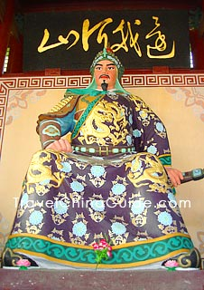
Statue of Yue Fei,
a famous general in
the Southern Song Dynasty
After the downfall of the Northern Song (960 - 1127), the Jin army captured many members of the imperial family, except Zhao Gou, the younger brother of the last emperor. In 1127, the Jin dynasty withdrew its troops from Kaifeng (capital of the Northern Song) and enthroned a puppet emperor. Due to the people's resentment of his betrayal of the Song Dynasty, he soon yielded the throne to Zhao Gou. However, due to continuous attacks by the Jin army, the newly-installed regime had to flee to Lin'an (currently Hangzhou in Zhejiang Province). In 1131, Lin'an was officially established as the capital of the Southern Song, with Zhao Gou as its first emperor - Emperor Gaozong.
War Affairs
From the establishment to the downfall, the Southern Song Dynasty never extricated itself completely from the endless battles with the Jin Dynasty (1115 - 1234) and the Mongolian Kingdom. To some extent the concept of ‘viewing literacy as more important than the military', put forth during the Northern Song Dynasty, guided the Southern Song's rulers, who tried any attempt to make peace with their enemies, contributing to continual alien invasions. That is why the Southern Song Dynasty is considered as the weakest dynasty in Chinese history.
With the Jin Dynasty
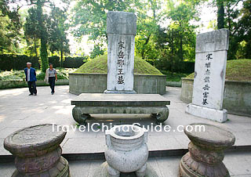
Tomb of General Yue Fei, Hangzhou
The territorial boundary between the Southern Song Dynasty and the Jin Dynasty was the Huaihe River and the Dasanguan Pass (in current Baoji City in Shaanxi Province). Since the founding of the Southern Song dynasty, the Jin court launched frequent attacks on the Song but each was repelled by the fierce resistance of the Song court's loyal generals. Among them, the most valiant was Yue Fei, who repeled the Jin army many times. Unfortunately, Yue Fei and his father were later falsely charged by a treacherous court official named Qin Hui and were executed by Emperor Gaozong.
After the reign of Emperor Gaozong, the relation between the Song and the Jin entered a comparatively stable stage. During Emperor Xiaozong's reign the Song court launched several northern expeditions in the hope of recovering the lost territory but they were in vain. By 1207 the military force of the Jin had gradually abated, while the newly-founded Mongolian regime became stronger. In 1214 when the Jin court plunged its troops southward another time, the Song army aligned itself with Mongolian army to fight against the Jin army. In 1234, the entire Jin regime was captured by the allied forces.
With Mongolian Kingdom
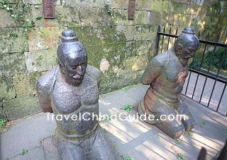
Iron statues of Zhang Jun and Mo Qixie,
who murdered Yue Fei
together with Qin Hui and his wife
Mongolian Kingdom was another strong enemy confronted by the Song court after the downfall of the Jin Dynasty. Immediately after the ruin of Jin, rulers of Song wanted to recover the lost territory by taking the advantage of the Mongolian troops' withdrawal, but the Song court failed to achieve this goal due to the weakness of its military force. Taking this act of the Song as an excuse, the Mongolians tried to invade southward several times, beginning in 1235, but they failed again and again because of the Song soldiers' bravery. However, the Song court did not take the opportunity of the Mongolians' withdrawal to recover the lost territory. Instead, the weak rulers of Song again initiated peace gestures, which foreshadowed the defeat of the Southern Song by the Mongolians.
Downfall
After the death of the former king of the Mongolians, his younger brother - Kublai Khan - became the new king. In 1271 Kublai Khan established a new dynasty - the Yuan (1271 - 1368). In 1276 the Yuan court launched a massive attack on the Southern Song, culminating in the capture of the Song's capital, Lin'an, and the downfall of the Southern Song.

