Branches of the Federal Government
Due to EP at Final Meeting!

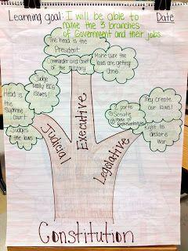

Above you can see an image of a simple (5th grade version) of the Branches of Government. As an 8th grade student, you are responsible for creating a more complex, detailed version of this Branches of Government Poster. Feel free to use a poster and draw it by hand, but I strongly encourage you to use one of the digital formats below to make your poster look professional. You are encouraged to invest a great deal of time researching and investigating content, as opposed to spending hours making it look pretty. However, the visual should look attractive and presentable.

Digital Formats: Please consider these options or email your teacher for other options you are considering and want approved. Avoid Using Power Point, this should be a poster, not a presentation.
- Infogr.am
- Easelly
- Pikochart
- Google Drawing

Requirements for your Poster:

- You must include all 3 branches of the federal government.
- For each branch (3) you will include the following:
  - Title of the Branch
  - Title of the “Job(s)” related to the branch (Executive = President)
  - Explanation of what the branch does.
  - At least one check that the branch has over another (search-checks and balances)
  - One image of a present member of that branch with a short explanation of who they are and what they stand for.
  - One image of an Historic (no longer “sitting” in position) member, with a short explanation of who they were and what they stood for.

- Lastly,once you are done with your poster, you must include a 2 paragraph response describing which branch of our government you think holds the most power. Be sure to use specific factual information, while adding in commentary to drive your point and persuade the reader as well!

You will submit by emailing a link to your poster to your EP or bringing in your poster before the grading deadline at your final meeting. Failure to turn in this project will negatively impact your grade. You must compete this to maintain your grade.

